Subscription Super Tag

This add-in is designed to add improve the process of tagging elements across various views in a model. A free version of this tool does not exist.

Contents

The User Form 1

Selecting a Category and Associated Tag 2

Selecting Family Types for Tagging 2

Selecting Views to Place Tags 2

Sample Demonstration 3

# The User Form

All functionality is provided within a single user form.

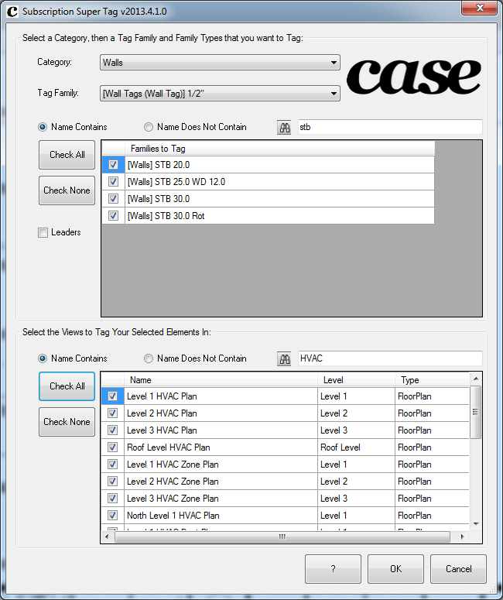

## Selecting a Category and Associated Tag

As the user selects a category from the drop-down menu at the top of the form, all associated tags currently loaded in the model get loaded into the “Tag Family” drop-down. The checkbox named “Leader” can be checked to enable leaders for all tags being placed by the utility.

## Selecting Family Types for Tagging

Each of the family types that are checked will get tags placed on their instance elements. There is a search box that will display the matching family and type names to make it easier to zero in on specific elements.

## Selecting Views to Place Tags

The lower portion of the form lists all views in the model where the user can select by checking the checkbox for which views they want to tag their selected family types. A search option is available to quickly find views by name that they are interested in placing tags for.

# Sample Demonstration

A vimeo file has been posted demonstrating the tool in Revit 2014. This tool is currently available as Revit 2012, 2013, and 2014.

<https://vimeo.com/63178735>